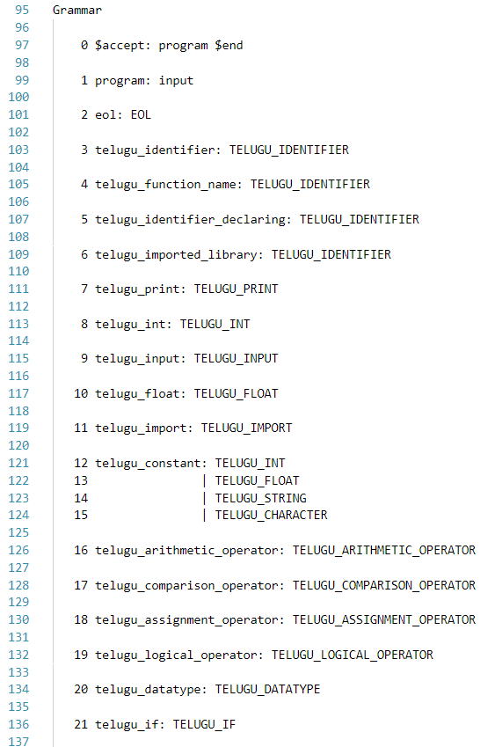 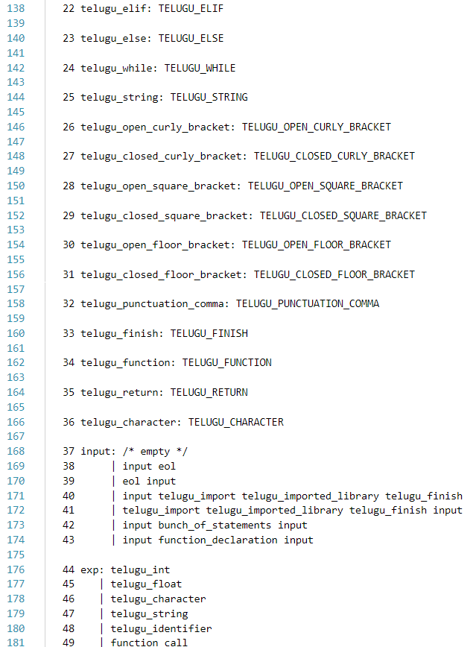

**TELUGU GRAMMAR RULES DEFINITION**

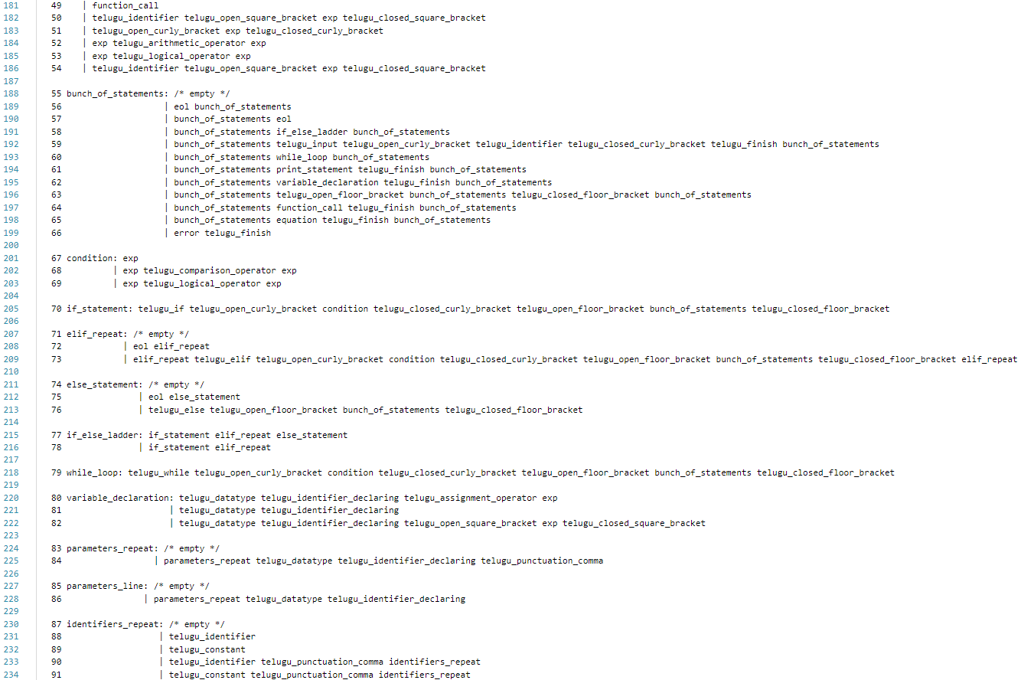

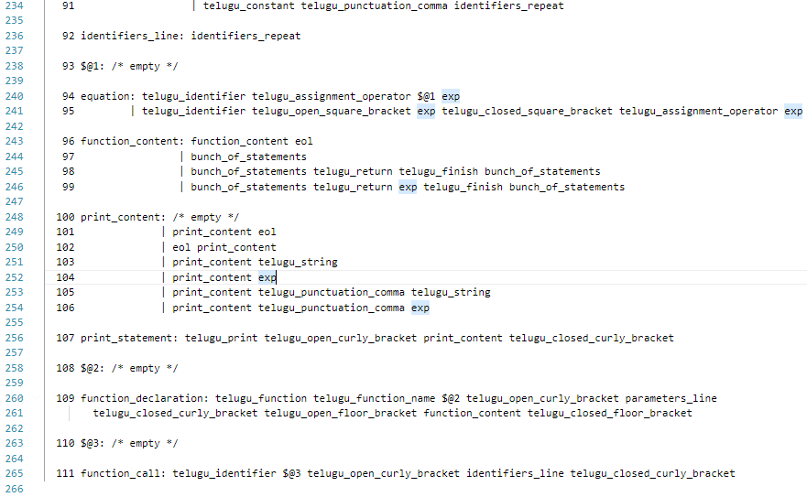

**Verbal Grammar Definition**

Variable Declaration:

sankhya a=3;

multiple variables declaration in the same line is not allowed like: sankhya a=3,b=4;

Headers:

thechko library_name;

multiple imports and renaming libraries like:

thechko lib1,lib2; // not allowed

thechko lib1 as my_lib; // not allowed

Function Declaration/Call:

function function_name(condition){

// bunch of statements

// function declarations not allowed in here

//can have return statement like ‘return;’ or ‘return exp;’

}

Input/Output Commands:

chupi(var1_value);

chupi(“any_string”);

chupi(“string1”, var1_value, “string2”, var2_value);

theesko(var1);

If-Else Ladder:

okavela(condition_1){ //flower braces are must

//bunch_of_statements

}

lekaokavela(condition_2){ // elseIf can repeat 0 or more number of times

//bunch_of_statements

}

lekapothe{ // need not be

//bunch_of_statements

}

Loop:

aithaunte(condition){ // only while loop allowed

//bunch_of_statements

}

Array Indexing:

sankhya arr[15];

arr[3];

arr[2+1*(x)+4]; // arr[any valid expression] is allowed

**PARSE TABLE:**

(Only few lines of the parse table are shown below)

